Example Word to Canvas Module document

# About this document

This document is provided to demonstrate and enable experimentation with the [word2canvas userscript](https://djplaner.github.io/word-to-canvas-module/). That userscript provides a way for to create a [Canvas module](https://www.instructure.com/en-au/canvas/resources/all/how-to-use-modules-to-build-courses-in-canvas) from a Word document.

Feel free to experiment, modify and provide feedback – [the Issues list](https://github.com/djplaner/word-to-canvas-module/issues) is a good place to report problems or ask questions.

## How to use this document

There are two main ways to use this document

1. Read it; or,  
   Read the text of the document and the Word comments to get some appreciation of the features and approach to authoring using word2canvas.
2. Use it.  
   With the [word2canvas userscript installed](https://djplaner.github.io/word-to-canvas-module/docs/install.html) you can use this document (and the pre-reqs in the following section) to create a Canvas module.

## Pre-requisites to create a Module with this document

If you use this document and word2canvas to create a module, it will work but there will be some errors reported. That's because this document assumes that your Canvas course includes the following existing resources

* A discussion titled *Introductions*
* An assignment called *Assignment 1*
* A classic quiz called *Classic Quiz Number 1*
* A number of files in the course's Files area, including
  + A copy of this document (or something with the same name).
  + A copy of [the Wikipedia logo](https://upload.wikimedia.org/wikipedia/en/thumb/8/80/Wikipedia-logo-v2.svg/103px-Wikipedia-logo-v2.svg.png) with the name wikipedia-logo.png

## Other useful pre-requisite knowledge

Word2canvas relies heavily on Word styles. Having a basic knowledge of [how to use Word styles](https://shaunakelly.com/word/styles/tipsonstyles.html), and their unique advantages and frustrations can be helpful.

## What it looks like in action

There is a [YouTube video](https://www.youtube.com/watch?v=WUU3kjT3Fj0) showing how to make use of this document with word2canvas.

Once you've used word2canvas, you can watch the YouTube video on the page via the following YouTube embed code. It's been pasted into this document and head the *embed* Word style applied. This tells word2canvas to treat it as HTML to display in Canvas.

<iframe width="560" height="315" src="https://www.youtube.com/embed/WUU3kjT3Fj0" title="YouTube video player" frameborder="0" allow="accelerometer; autoplay; clipboard-write; encrypted-media; gyroscope; picture-in-picture" allowfullscreen></iframe>

# Create a new page in the module

This new *Heading 1* style tells word2canvas to create a new page in the module. The title of the page will match the text in the heading – *Create a new page in the module*. ***That's a really bad title for this page – fix it.***

# Introducing the word2canvas Word styles

Word2canvas recognises a list of specific Word styles – summarised in the following table. Each Word style directs word2canvas to make specific changes to the content. e.g. a *Heading 1* style means create a new page in the Canvas module.

Some of these styles rely on some resources (e.g. discussions, quizzes, assignments, files etc) already existing in the Canvas course site. e.g. the *Existing Canvas Page* is a heading 1 style, but rather than create a new page, it looks for a page already in the course site and adds it to the module. If there is no such existing page, then there's an error.

The rest of this document provides some explicit examples of each of these special styles.

## Heading styles

Except for the *Title* style, the styles in the following tables are "heading" styles. i.e. they are based on the Word *heading* 1 style and will add a new item to the module being created by word2canvas.

The type of item being added depends on the style, but can include: a new or existing page; a quiz; a module sub-header; a file etc.

|  |  |
| --- | --- |
| **w2c style** | **Purpose** |
| Title | The title of the new [Canvas module](https://community.canvaslms.com/t5/Canvas-Basics-Guide/What-are-Modules/ta-p/6) |
| Heading 1 | Name of a new [Canvas page](https://community.canvaslms.com/t5/Canvas-Basics-Guide/What-are-Pages/ta-p/5) |
| Existing Canvas Page | Name of a Canvas page already available in the course |
| Canvas Discussion | Name of an existing [Canvas discussion](https://community.canvaslms.com/t5/Canvas-Basics-Guide/What-are-Discussions/ta-p/3) |
| Canvas SubHeader | Name for a new [Canvas text (sub) header](https://community.canvaslms.com/t5/Instructor-Guide/How-do-I-add-a-text-header-as-a-module-item/ta-p/1208) |
| Canvas File | The name (or part of the name) of a file already in the Canvas course's [Files](https://community.canvaslms.com/t5/Canvas-Basics-Guide/What-are-Files/ta-p/7) |
| Canvas Assignment | The name (or part of the name) of an assignment already in the Canvas course's [Assignments](https://community.canvaslms.com/t5/Canvas-Basics-Guide/What-are-Assignments/ta-p/9) |
| Canvas Quiz | The name (or part of the name) of a quiz already in the Canvas course's [Quizzes](https://community.canvaslms.com/t5/Canvas-Basics-Guide/What-are-Quizzes/ta-p/68) |
| Canvas External Url | Add an [external link as a module item](https://community.canvaslms.com/t5/Instructor-Guide/How-do-I-add-an-external-URL-as-a-module-item/ta-p/967) |
| Canvas External Tool | Add an [external tool as a module item](https://community.canvaslms.com/t5/Instructor-Guide/How-do-I-add-an-external-tool-as-a-module-item/ta-p/1146) |

## Inline styles

The following "inline" styles do not add a new item to the module being created. Instead, they are used to modify content to the current Canvas page which is being added to the module.

|  |  |
| --- | --- |
| **w2c style** | **Purpose** |
| Canvas File Link | Insert a link to a Canvas file within a page. Apply this style to some text and it assumes that the text is the name of the file that it should link to. Apply this style to a link, then it assumes the link is the name of the file. |
| Canvas Menu Link | This style is applied to a link in the Word document – e.g. link to the Modules page of my course The address in the link is the name of a menu item in the Canvas course menu (e.g. *Modules*). In Canvas, this name is replace with the actual link to the menu item |
| placeholder | Used to highlight some text that is a placeholder. i.e. text that should be replaced at a later date with some other value. |
| hide | Any content with the *hide* style will not be added to Canvas. |
| Blackboard Image | Applied to embedded HTML img tag. i.e. specifies a link to an image. But the src for the image is the name of a file within the Canvas files area. In Canvas, the filename will be replaced with the URL of the matching file |

# And also the "content interface" styles

The [Content Interface](https://djplaner.github.io/Content-Interface-Tweak/) is a tweak used to author content for Blackboard. It's the direct ancestor of word2canvas. As such and to help with migration from Blackboard to Canvas, word2canvas also supports some "content interface" styles. Currently, these don't quite work in Word the same way as real Content Interface styles – a migration artefact.

They are summarised in the following table with detailed examples below. Most are special styles to indicate a particular learning design. All of these styles are "inline" styles.

|  |  |
| --- | --- |
| **"content interface" styles** | **Purpose** |
| Flashback | Used to style text and add visual identity for the "flashback" learning activity |
| Weekly Workout | Used to style text and add visual identity for the "weekly workout" learning activity |
| Canary Exercise | Used to style text and add visual identity for the "canary exercise" learning activity |
| Note | Style some text to be displayed as a note along with a warning icon |
| activity | Used to style text and add visual identity to a general "activity" |
| Added Advice | A style applied to descriptive, smaller text added to a video or some other artefact |
| Reading | Used to style text and add visual identity for the "reading" learning activity |
| Coming Soon | Used to style text and add visual identity for the "coming soon" learning activity |
| Picture | Applied to an image (and caption) will apply some additional styling |
| PictureRight | Similar styling to "picture", but the image is also floated to the right. i.e. so other text can flow to the left. |
| Quote | Used to apply special formatting to a quotation |
| Poem | Apply special formatting to a poem |
| Poem Right | Same as "poem", but floats the poem to the right. |

* Demonstrating the word2canvas styles

A Canvas sub header item doesn't have any additional content. Hence the content of this section is ignored.

# Setting up the use of *Existing Canvas Page*

This section starts with a *Heading 1* style. This will add a new Canvas page to the module created by word2canvas.

The following section starts with the *Existing Canvas Page* style. It's also a heading 1 and will result in a page being added to the new module. However, as the name suggests this page will not be a new page. It will be a page that already exists in the Canvas course.

If you compare the heading text – *About this document* – with the first heading in this document, you should see that they are the same. In theory, this means that word2canvas should add this page to the module twice.

The first time will be at the start of the module and it will be a new page. The second time will be the page following this, but it will be the same module.

* About this document

This content will be ignored. As the heading here is using the *Existing Canvas Page* style, it ignores all the content until the next heading 1. The content that will appear will be from the existing page called *About this document*. i.e. should be the first section of this document

* Introductions

For similar reasons, the content in this section will be ignored.

The Heading 1 in this case is using the *Canvas Discussion* style. It will try to add here an existing discussion called *Introductions*.

* Link to sample document (by name)

sample w2c.docx

* Assignment 1

# Another new page

Just to break up the content. The four previous headings will generate errors if the required resource doesn't exist.

Similarly, the next heading – which has a *Canvas Quiz* style – will generate an error if there isn't a Canvas classic quiz called *Classic Quiz Number 1*.

* Classic Quiz Number 1
* Cric Info

https://www.espncricinfo.com/

* Anything in echo?

https://echo360.net.au/lti/337d14d7-fede-434e-b5af-81dc0a25f67e

# FAQs and Accordions

An [accordion interface](https://uxdesign.cc/ui-cheat-sheet-accordions-3e88f0d4dfee) is one way to aid navigation of complex content. word2canvas supports two simple ways to implement accordion interfaces.

## FAQs

The *FAQ Heading 1* and *FAQ Body 1* styles are used to support Frequently Asked Questions. Where the question is the accordion heading and the body is the answer.

It's a simple and somewhat constrained implementation.

* Heading for the FAQ – becomes the accordion title

Use the *FAQ Body 1* style as the body of the accordion. But it is somewhat constrained

## Convert Heading 2 styles to accordions

When using word2canvas there is an option to turn all Heading 2s into an accordion. No additional change is required within the Word document. Any Heading 2 will become an accordion.

# Examples of inline styles

The previous items all demonstrated the "heading" styles. Word2canvas styles which are based on the *Heading 1* style and work to add new items to the Canvas module being created.

The "inline" styles shown here work within the content of a page in the new module.

Hide is content that will not make it into Canvas

But this will appear.

## Linking to resources using their name, not their URL

The idea here is that rather than manually visit the Canvas course site and discover the URL for a file or a menu item, we can just use the name. If we use the right style, word2canvas will find the URL and replace the name.

### Link to a file

We can also link to a file – e.g. a copy of this Word document.

### Link to a menu item

Or we can link to one of the menu item – e.g. the Modules page.

### Show an image

This is a little more complicated

<img src="wikipedia-logo.png" alt="local copy of the Wikipedia logo" />

And for attribution, I've used the *embed* style to include HTML with attribution information for the logo from Wikipedia.

<p>By Version 1 by <a href="https://meta.wikimedia.org/wiki/User:Nohat" class="extiw" title="meta:User:Nohat">Nohat</a> (concept by <a href="https://meta.wikimedia.org/wiki/User:Paullusmagnus" class="extiw" title="meta:User:Paullusmagnus">Paullusmagnus</a>); Wikimedia. - <a href="//commons.wikimedia.org/wiki/File:Wikipedia-logo.svg" class="mw-redirect" title="File:Wikipedia-logo.svg">File:Wikipedia-logo.svg</a> as of <a class="external text" href="https://upload.wikimedia.org/wikipedia/commons/archive/8/80/20100615232840!Wikipedia-logo-v2.svg">14 May 2010T23:16:42</a>, <a href="https://creativecommons.org/licenses/by-sa/3.0" title="Creative Commons Attribution-Share Alike 3.0">CC BY-SA 3.0</a>, <a href="https://commons.wikimedia.org/w/index.php?curid=10337301">Link</a></p>

# What doesn't work? Unknown styles, formatting, and embedded images

Word documents and web pages take very different approaches to formatting and styling content. To bridge this gap word2canvas is designed to use Word's styles and provide some support for other ways of formatting content. But not everything works.

## Most normal direct formatting won't work

[Direct formatting](https://www.formattingfundamentals.com/direct-formatting-word/) is when you manually change the styling of some text directly. e.g. you use **bold** or *italics* or ***both*** or you highlight some text, perhaps change the background colour, or the font colour, or maybe the font size. Perhaps ~~strike-through~~, underline, superscript etc.

Word2canvas will not recognise many of these. Generally, word2canvas only recognises formatting via the use of specific styles.

For example, the above section looks like the following when placed into Canvas by word2canvas

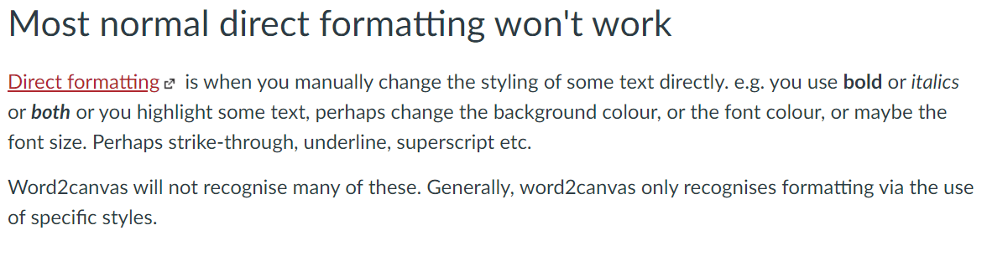

## Unrecognised Word styles won't work

Word2canvas only recognises some Word styles. More can be added – ask and you might receive.

If you use some strange style – like the next – word2canvas will complain that it doesn't recognise it as demonstrated in the following image.

* Some strange style.

The image below is a screenshot of word2canvas complaining about unrecognised styles, including the circled *Some Strange Style*.

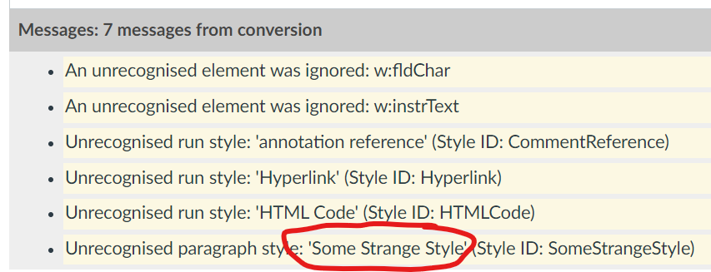

## Embedded images won't work

Word2canvas currently isn't smart enough to import images embedded into Word. For example, after adding the previous image word2canvas's errors look like the following image. The *base64* image error is new.

**This is a feature to be added ASAP.**

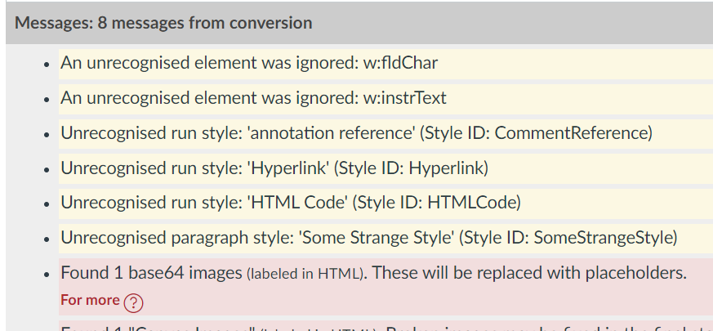

* Examples of 'content interface' styles

# About the 'content interface' styles

As currently implemented most of these styles are implemented pragmatically to aid migration of Content Interface content from Blackboard to Canvas.

Hence using these styles is not exactly "proper" Word authoring. It's a kludge.

# Flashback, Weekly Workout, and Canary Exercise

Each of these styles were from a particular learning design and had specific meanings for that course

## Flashback

Start

Anything that goes here will be within the flasback

End flashback – text in these coloured paragraphs will be removed in Canvas

## Weekly workout

Start

And just what ever content you want within

## Even a heading might work

As will a [link to Google](https://google.com).

End

## Canary exercise

Start

And here is the canary exercise

End

# Reading, Activity, Coming Soon

Continuing much the same as the previous

## Reading

Start

Details of some reading goes here

End

## Activity

Start

Some activity details

And some more

End

## Coming Soon

Start

* Some activity
* Another topic
* Activity 2
* Topic again

End

# Note and added advice

## Note

Start the note

The idea of the note is to focus attention on some important consideration in the context of the flow

End the note

## Added advice

Originally, added advice was used to automatically added some advice about using Stream

Start

Small instructions to be added

End

# Picture and PictureRight

Start PictureRight

<img src="wikipedia-logo.png" alt="local copy of the Wikipedia logo" />

And this is the caption

End

The picture styles are both designed to be used with images.

The only good way of including images currently is via HTML embeds.

The picture right example at the beginning of this section is using a Blackboard Image style to link to an image in the Canvas Files area.

Because it is a Picture Right style it will float to the right and this text will flow to the left of it.

Kind of way this long list of separate paragraphs is being used.

Start picture

<img src="https://upload.wikimedia.org/wikipedia/commons/thumb/e/e1/Lotus_flower_at_West_Lake%2C_Hangzhou_%282790886703%29.jpg/450px-Lotus_flower_at_West_Lake%2C_Hangzhou_%282790886703%29.jpg" alt="Lotus Flower with water and lily pads in the background" />

And some longer caption

At the bottom of this picture

End

# Last page of this module – at least it used to be

The end of this module and some other examples

<iframe width="560" height="315" src="https://www.youtube.com/embed/mPbclTnMLlc" title="YouTube video player" frameborder="0" allow="accelerometer; autoplay; clipboard-write; encrypted-media; gyroscope; picture-in-picture" allowfullscreen></iframe>

* Talking about indenting items

Indenting Canvas Module items using word2canvas

Canvas [Module items can be indented](https://teacherscollege.screenstepslive.com/a/790009-indent-a-module-item-in-canvas). There are 5 levels of indentation. The following explains how you indent module items in word2canvas.

## Word2canvas: “Heading 1” styles define module items

Each of the Word styles (recognised by word2canvas) listed in the following table are baed on the standard Word *Heading 1* style.

Each of these styles match a particular type of Canvas module item.

By default, all of these items will not be indented. To indent an item, you need to use a modified style name…

|  |  |
| --- | --- |
| **w2c style** | **Purpose** |
| Heading 1 | Name of a new [Canvas page](https://community.canvaslms.com/t5/Canvas-Basics-Guide/What-are-Pages/ta-p/5) |
| Existing Canvas Page | Name of a Canvas page already available in the course |
| Canvas Discussion | Name of an existing [Canvas discussion](https://community.canvaslms.com/t5/Canvas-Basics-Guide/What-are-Discussions/ta-p/3) |
| Canvas SubHeader | Name for a new [Canvas text (sub) header](https://community.canvaslms.com/t5/Instructor-Guide/How-do-I-add-a-text-header-as-a-module-item/ta-p/1208) |
| Canvas File | The name (or part of the name) of a file already in the Canvas course's [Files](https://community.canvaslms.com/t5/Canvas-Basics-Guide/What-are-Files/ta-p/7) |
| Canvas Assignment | The name (or part of the name) of an assignment already in the Canvas course's [Assignments](https://community.canvaslms.com/t5/Canvas-Basics-Guide/What-are-Assignments/ta-p/9) |
| Canvas Quiz | The name (or part of the name) of a quiz already in the Canvas course's [Quizzes](https://community.canvaslms.com/t5/Canvas-Basics-Guide/What-are-Quizzes/ta-p/68) |
| Canvas External Url | Add an [external link as a module item](https://community.canvaslms.com/t5/Instructor-Guide/How-do-I-add-an-external-URL-as-a-module-item/ta-p/967) |
| Canvas External Tool | Add an [external tool as a module item](https://community.canvaslms.com/t5/Instructor-Guide/How-do-I-add-an-external-tool-as-a-module-item/ta-p/1146) |

## “Heading 1” + *indent X* style names define indentation

The addition of **– indent 1** to the Heading 1 style names from the table above will indent the item 1 level. **– indent 3**will indent the item 3 levels. The following table has more examples.

|  |  |
| --- | --- |
| w2c style | Effect |
| Heading 1 – indent 3 | Create a new [Canvas page](https://community.canvaslms.com/t5/Canvas-Basics-Guide/What-are-Pages/ta-p/5) but indent it 3 levels when adding to the module |
| Existing Canvas Page – indent 2 | Add a Canvas page already available in the course matching the text, but indent it 2 levels |
| Canvas Discussion – indent 5 | Add an existing [Canvas discussion](https://community.canvaslms.com/t5/Canvas-Basics-Guide/What-are-Discussions/ta-p/3) matching the text, but indent 5 levels |

#### Heading 4 to keep it there?

##### Heading 5

A new page – indented 1

The above style is the *Heading 1 – indent 1*

A new page – indented 5

The above style is the *Heading 1 – indent 5* style

* Some existing pages indented to different levels

# Explanation

Each of the following will link to existing pages (one defined above) but they will be indented to different levels

* Last page of this module – at least it used to be

Last page of this module – at least it used to be

Last page of this module – at least it used to be

Last page of this module – at least it used to be

Last page of this module – at least it used to be

Last page of this module – at least it used to be

* And canvas sub headers can be indented

By 1

By 2

By 3

By 4

By 5